Jmecherie PS
The meaning of the interface Segregation Principle is
The meaning of the Dependenct Inversion Principle includes (doar a si c)
The meaning of the Single Responsibility Principle is

The meaning of the Open-Closed Principle is
The meaning of the Liskov Substitution Principle is



Which of the following are good design principles
Which of the following are good criteria for grouping classes together
The stability of a package in design
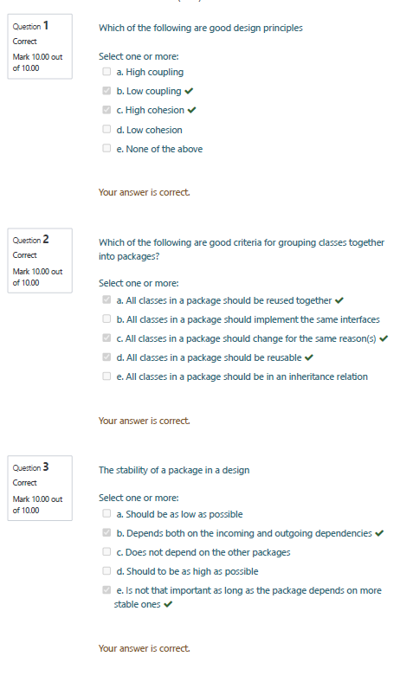
Abstract packages
The dependency structure of the packages of a release component
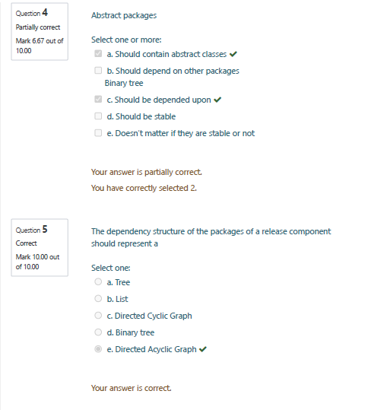
Suitable solution(s) for a decoupled, distributed architecture of heterogenous, independent components/services is(are)
Which of the following are good practices for a layered architecture

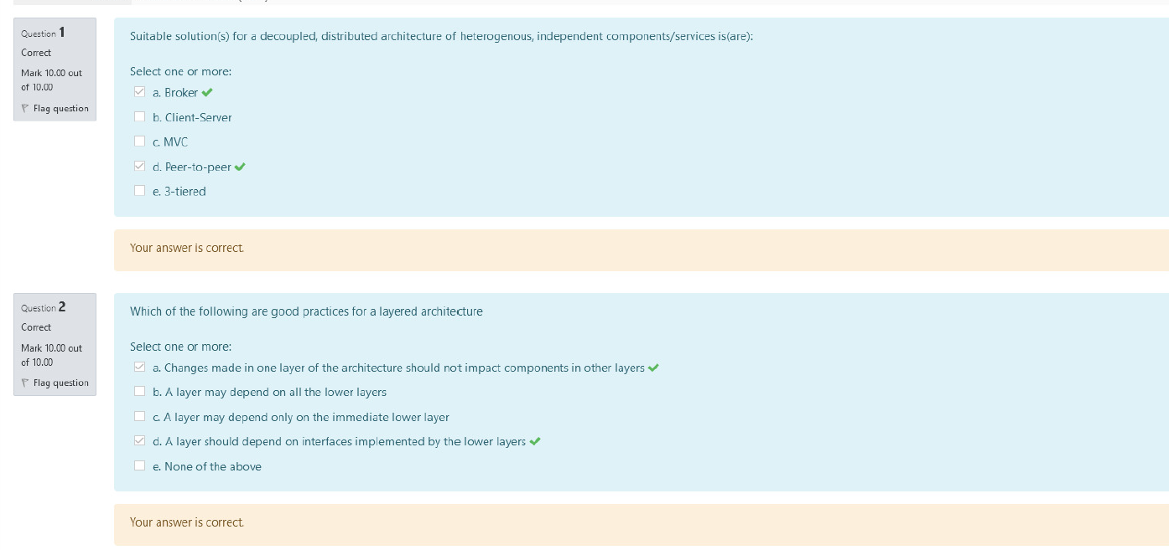
Which of the following statements is true (ViewModel, MVC)
Which statements are true about MVC

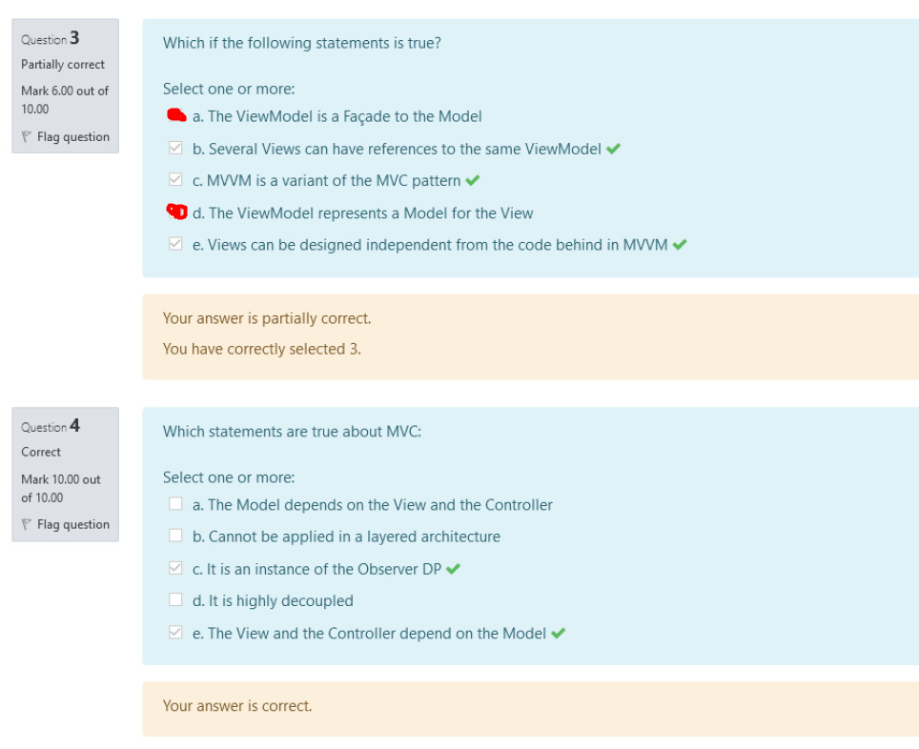
The Broker component in the Broker pattern

Consider Service design principles we can state that 
Aggregates in the context of DDD
What is true about SOAP based services
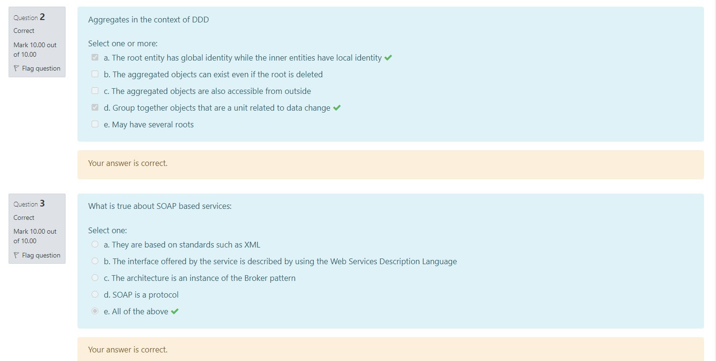
REST services are different from SOAP-based services because

In the context of Domain driven design the following statements hold
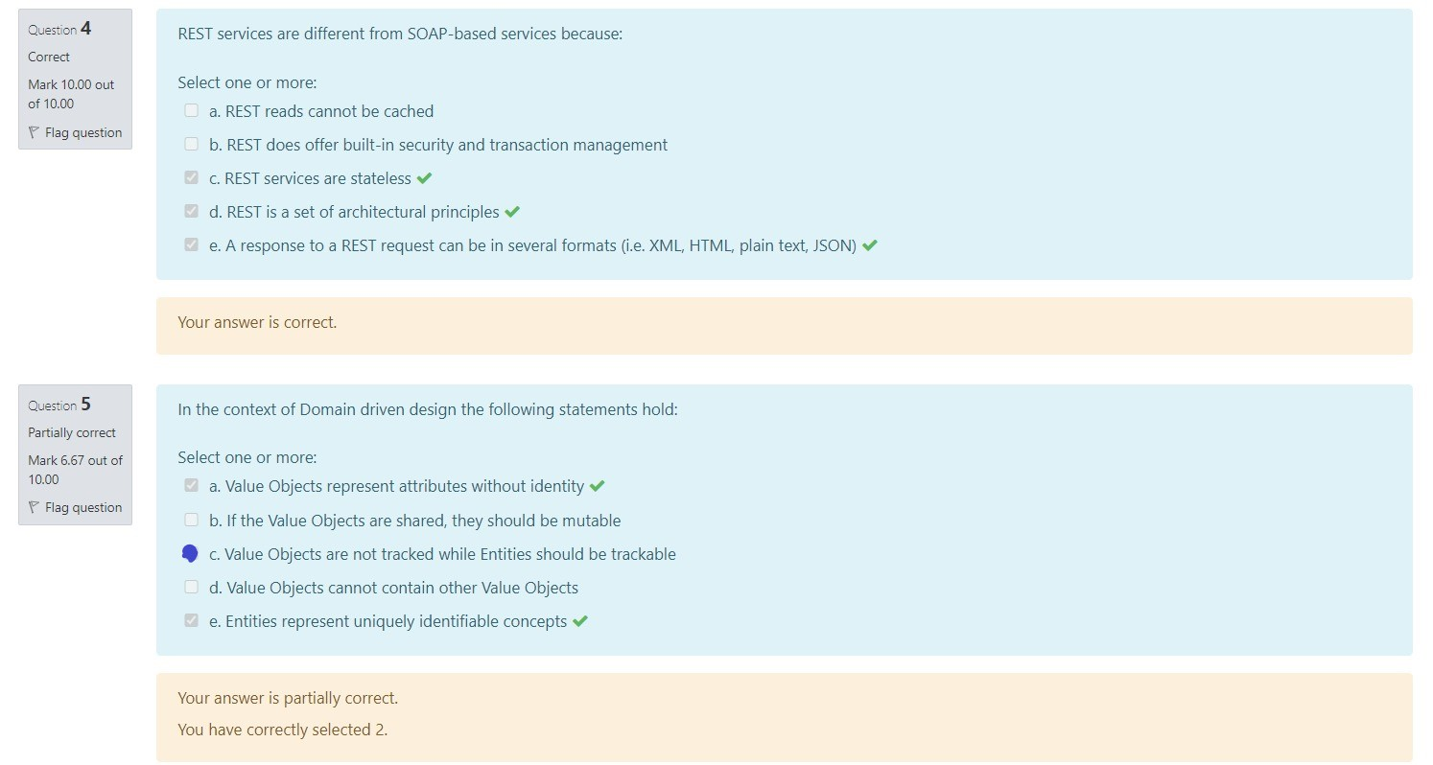
Some best practices in the iDesign method are
In the iDesign method
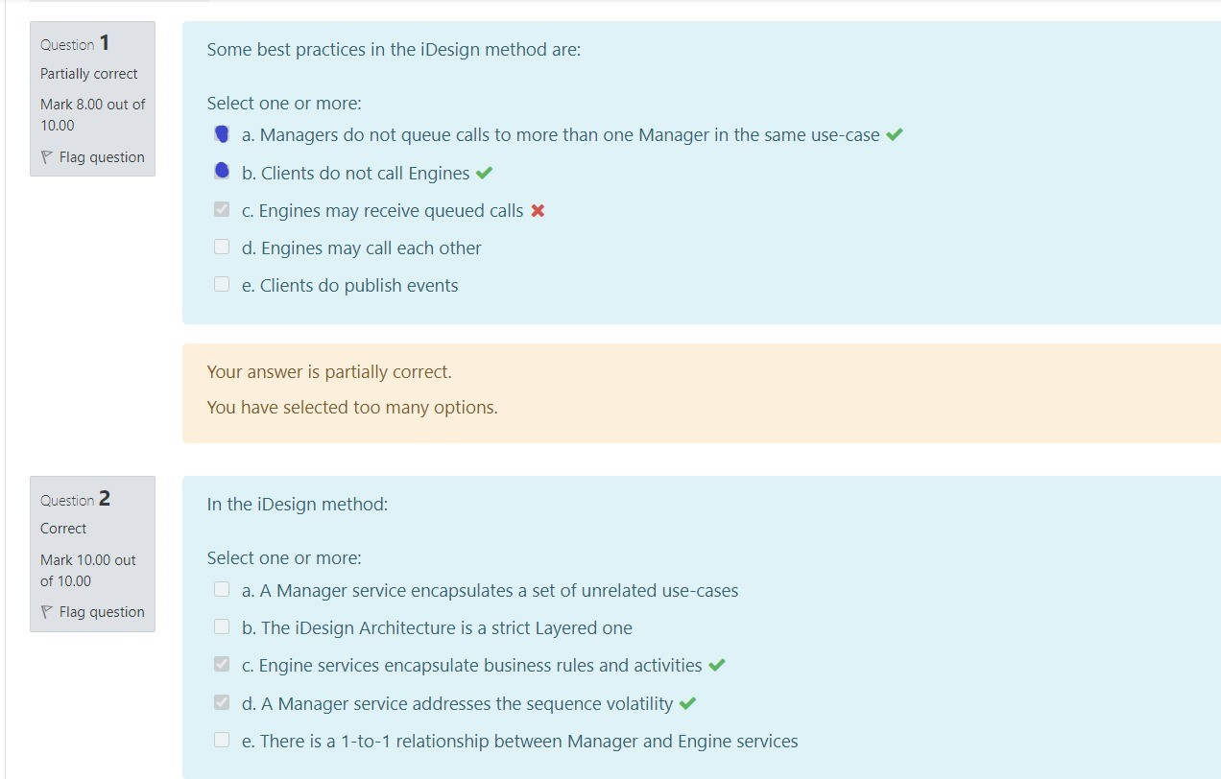
The following is true about orchestration and choreography
The following is true in the iDesign method
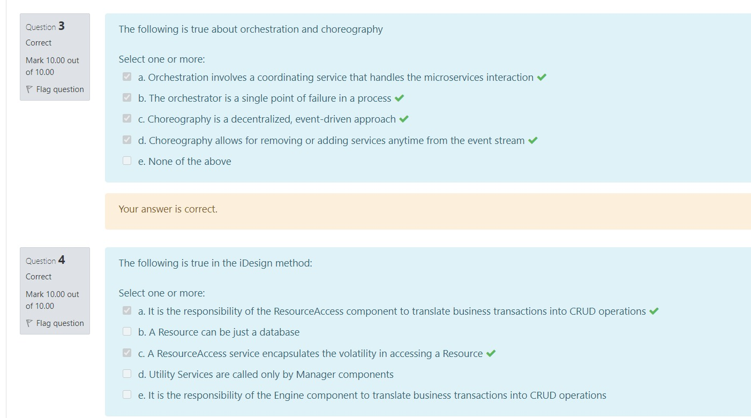
Very small services (microservices) have consequences such as

The responsibilities of the Data access components are

The following is true about the Data Mapper

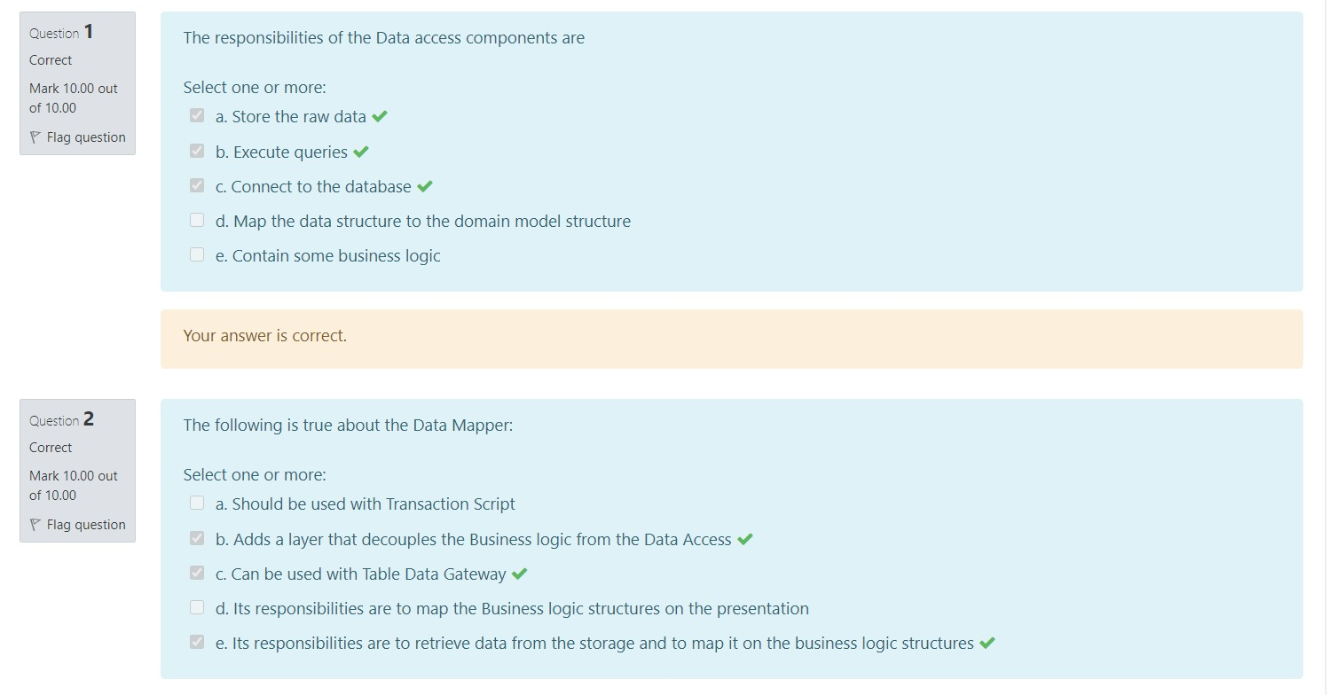
Transaction script is an example of business logic design based on
Considering how inheritance is reflected in a relational database structure the following is true
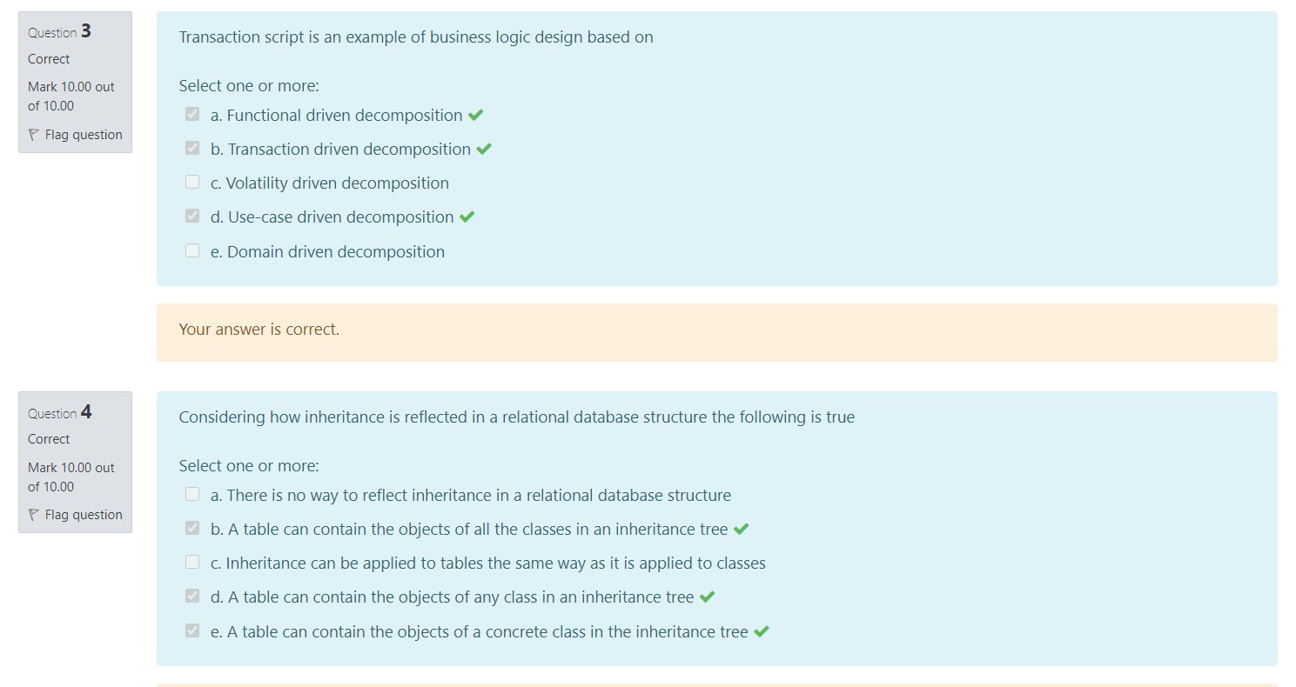
Active Record violates the following principle(s)


The Transform View
The Unit of Work pattern is used to

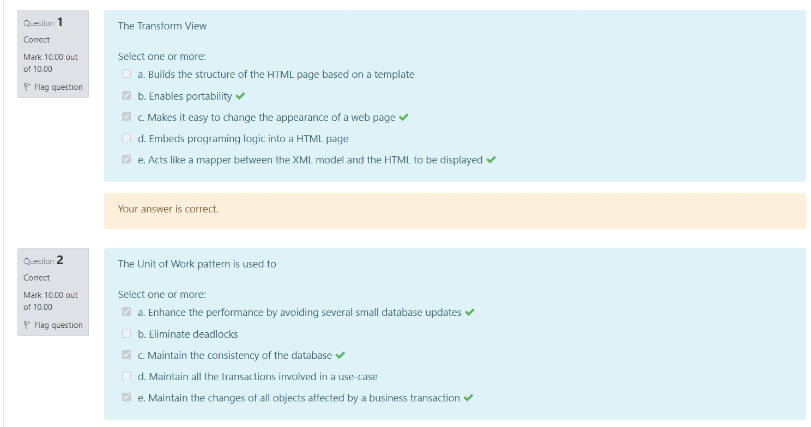
A Page Controller

A transaction has the following properties
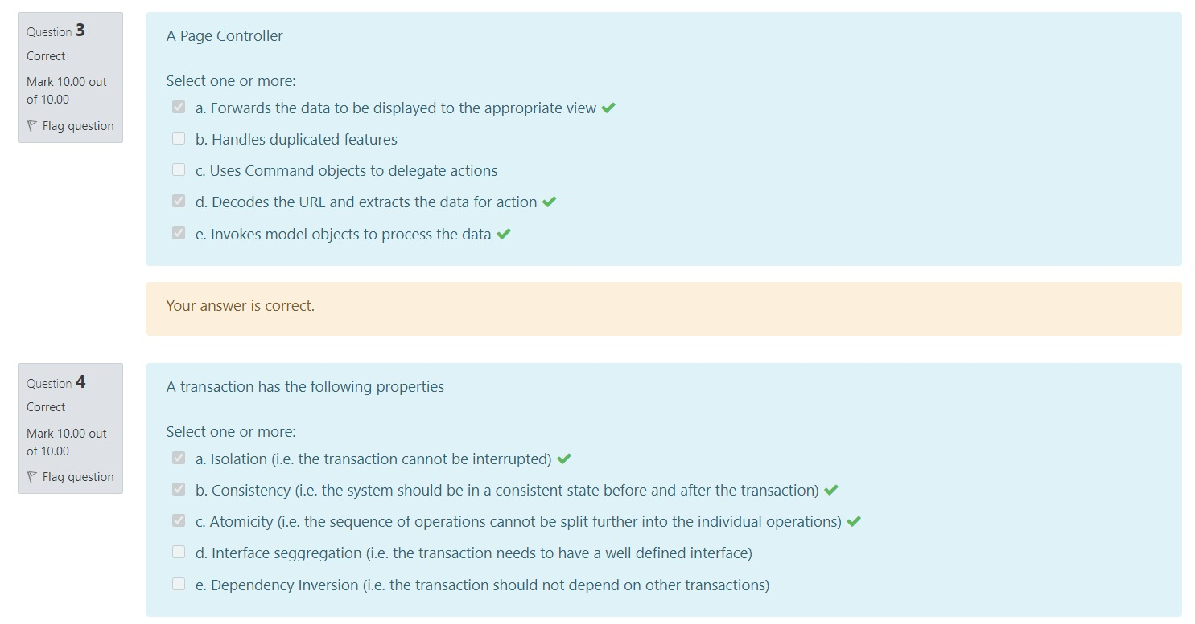
The following is true about concurrency control
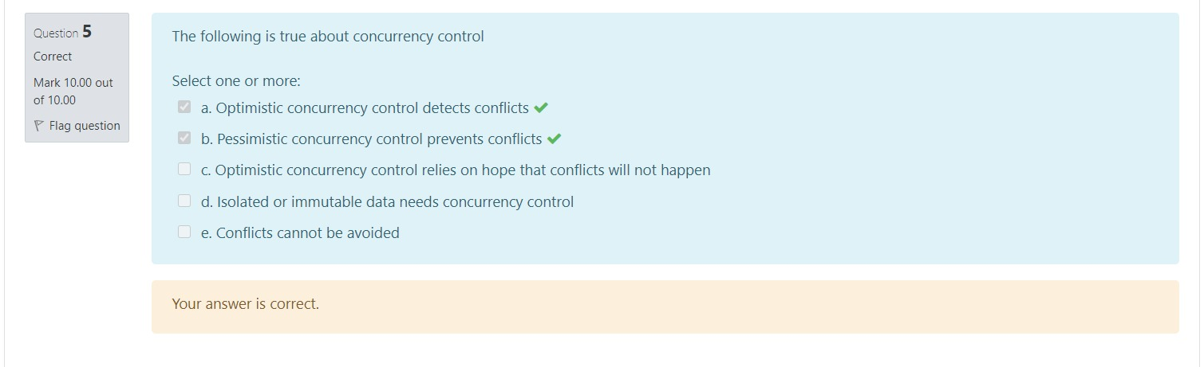
The Abstract Factory is used to

A factory method
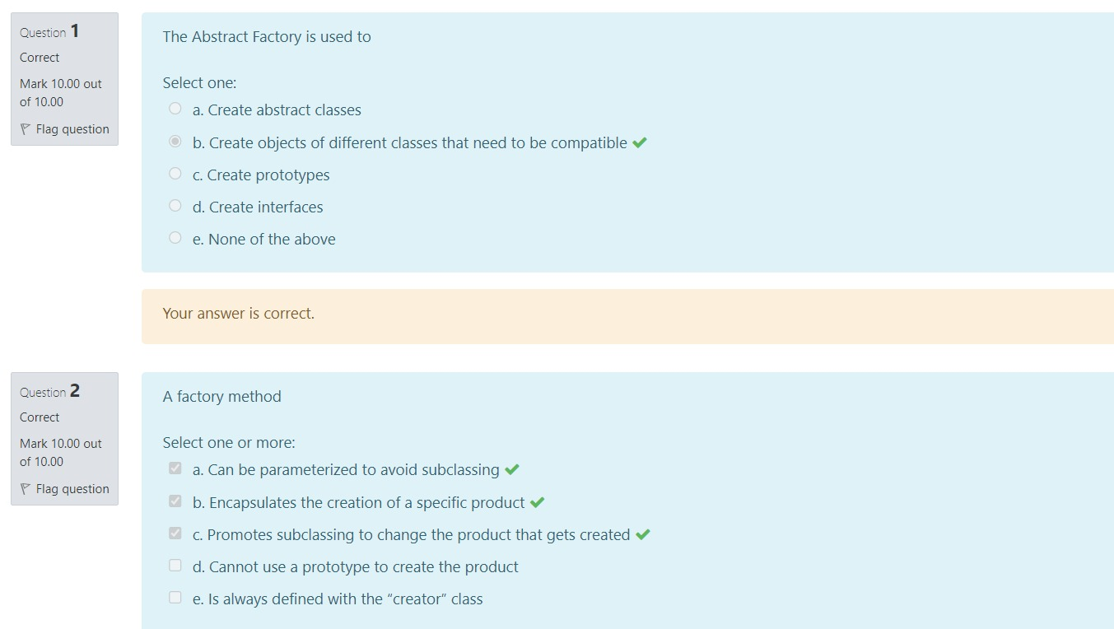
A prototype object
To create a class that allows to be instantiated in a fixed number of objects we have to

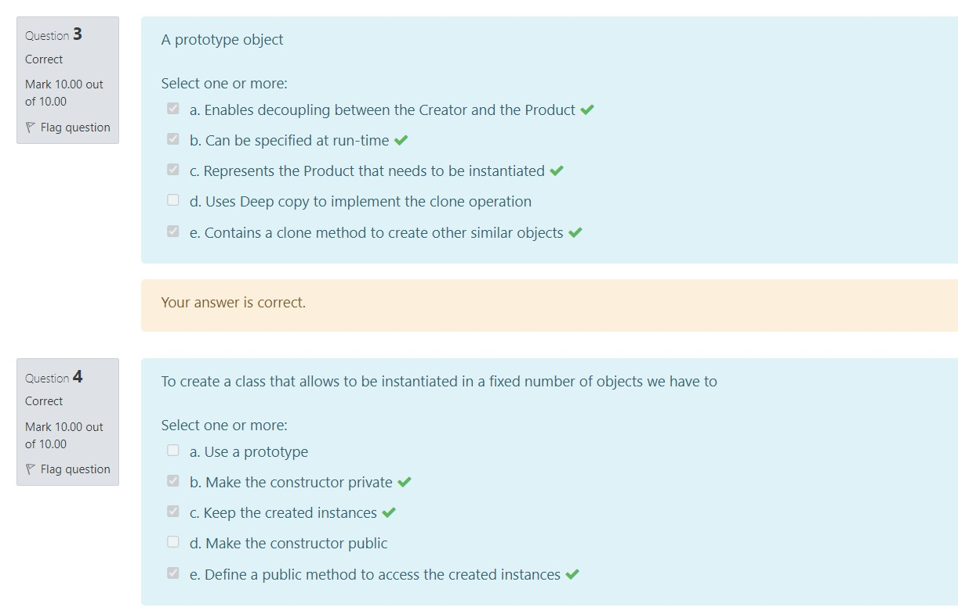
An Abstract Factory can contain
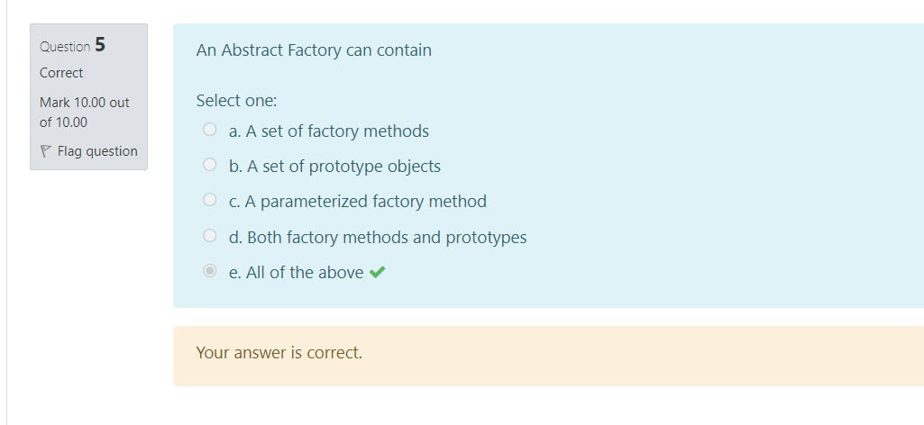
What strategies is the Bridge Design pattern applying
From the Clients perspective, the objective of the Adapter Design pattern is to

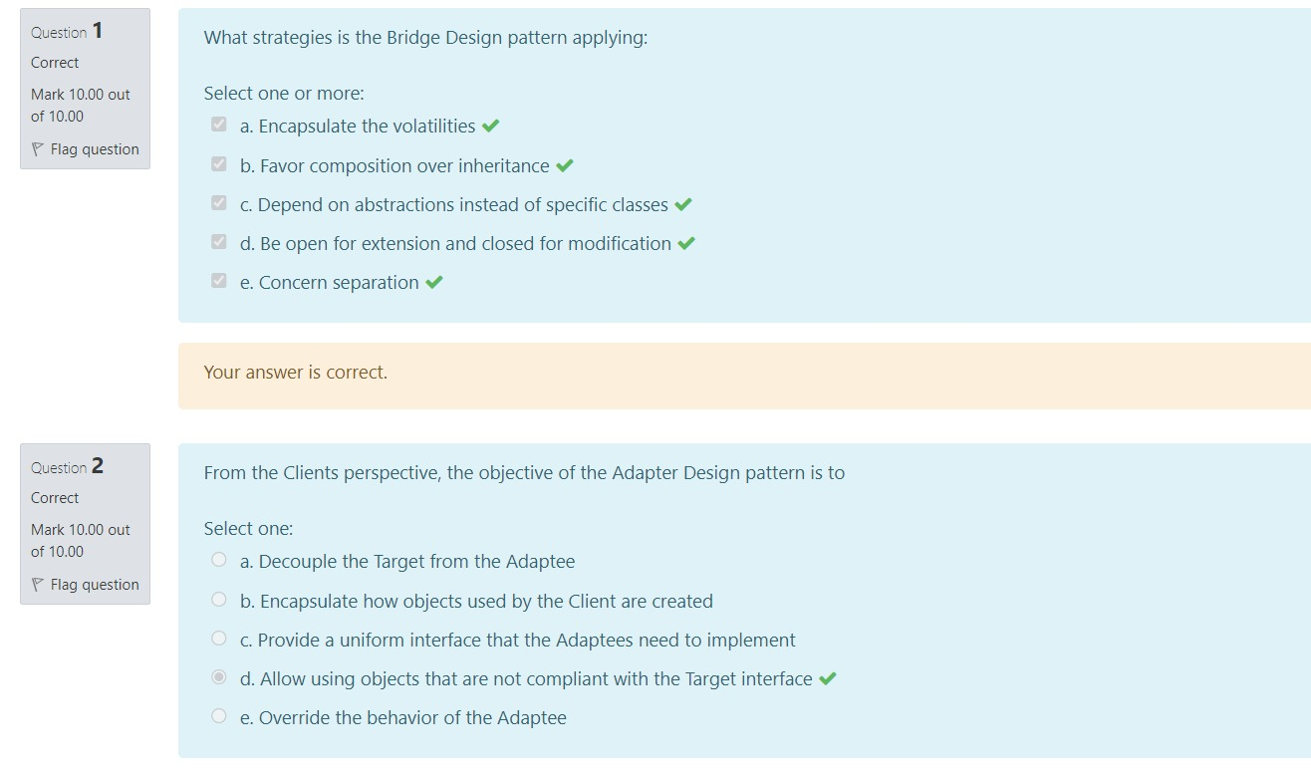
If we want to define a standard car and several options that could be added to build a custom car we would use the following design patterns
A site displaying a blurred, low-resolution copy of the images instead
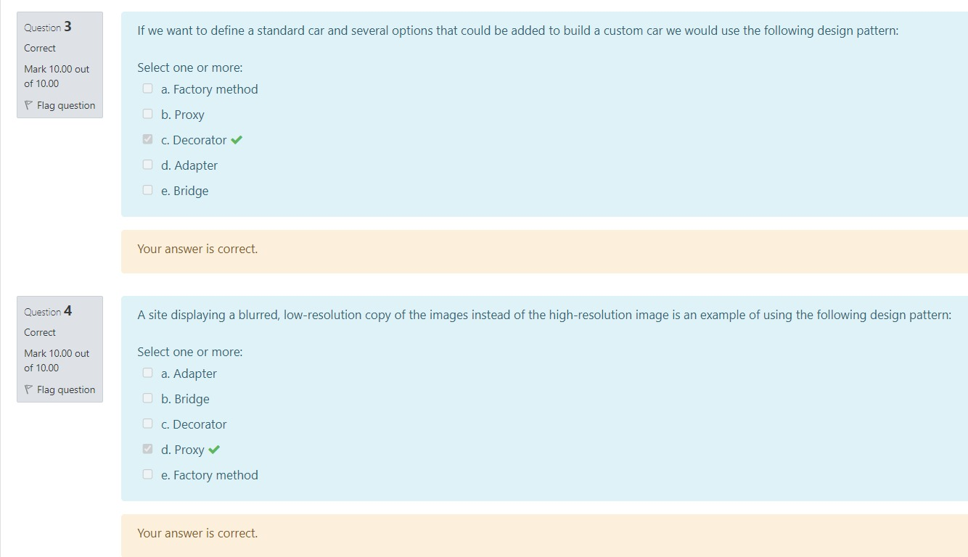
The following is true about the Composite pattern
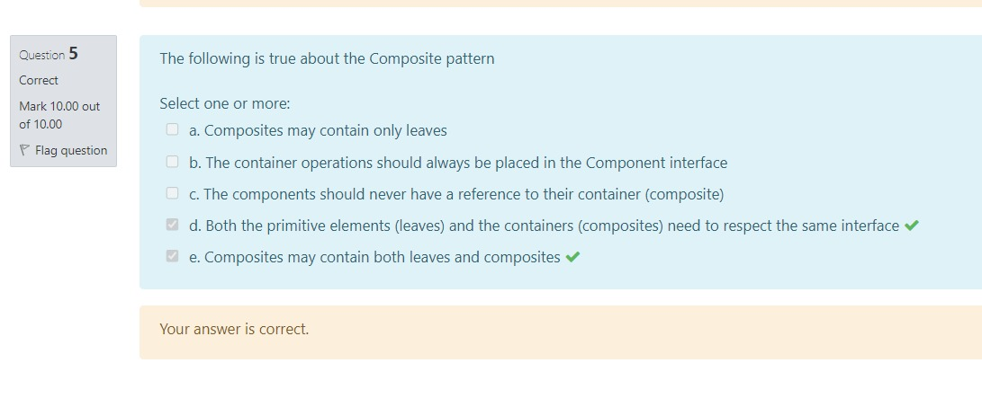
Considering the Chain of responsibility DP
Which DP(s) is/are more suitable to model the concept of a thread considering its lifecycle

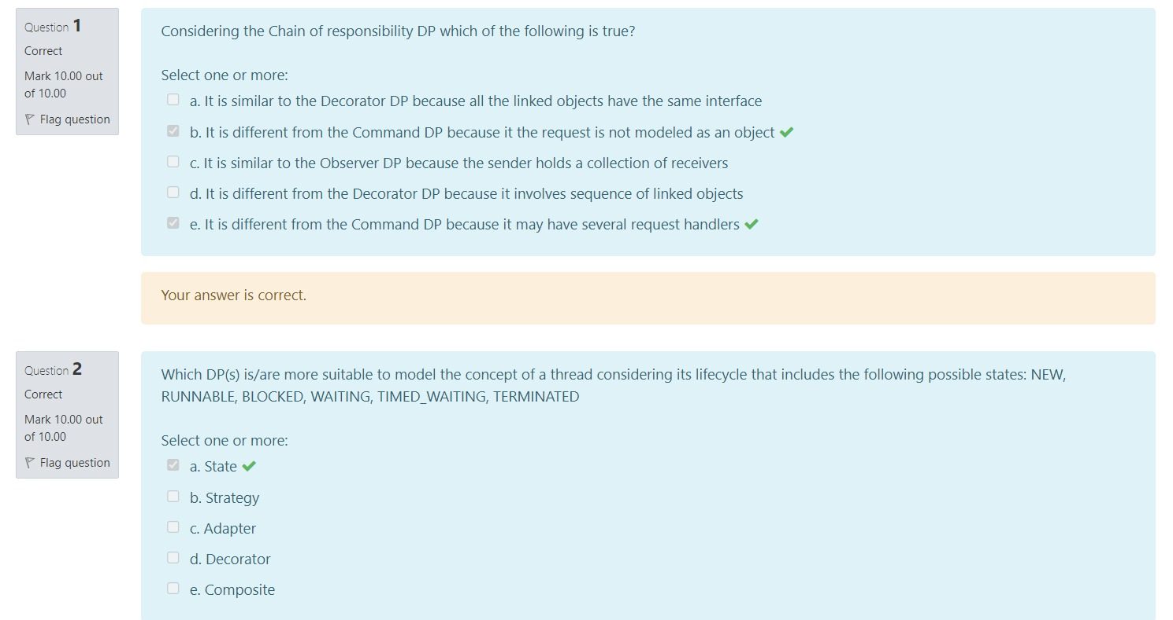
Which DP(s) are more suitable to model the transportation from the hotel to the airport
The following is an example of applying the Observer DP
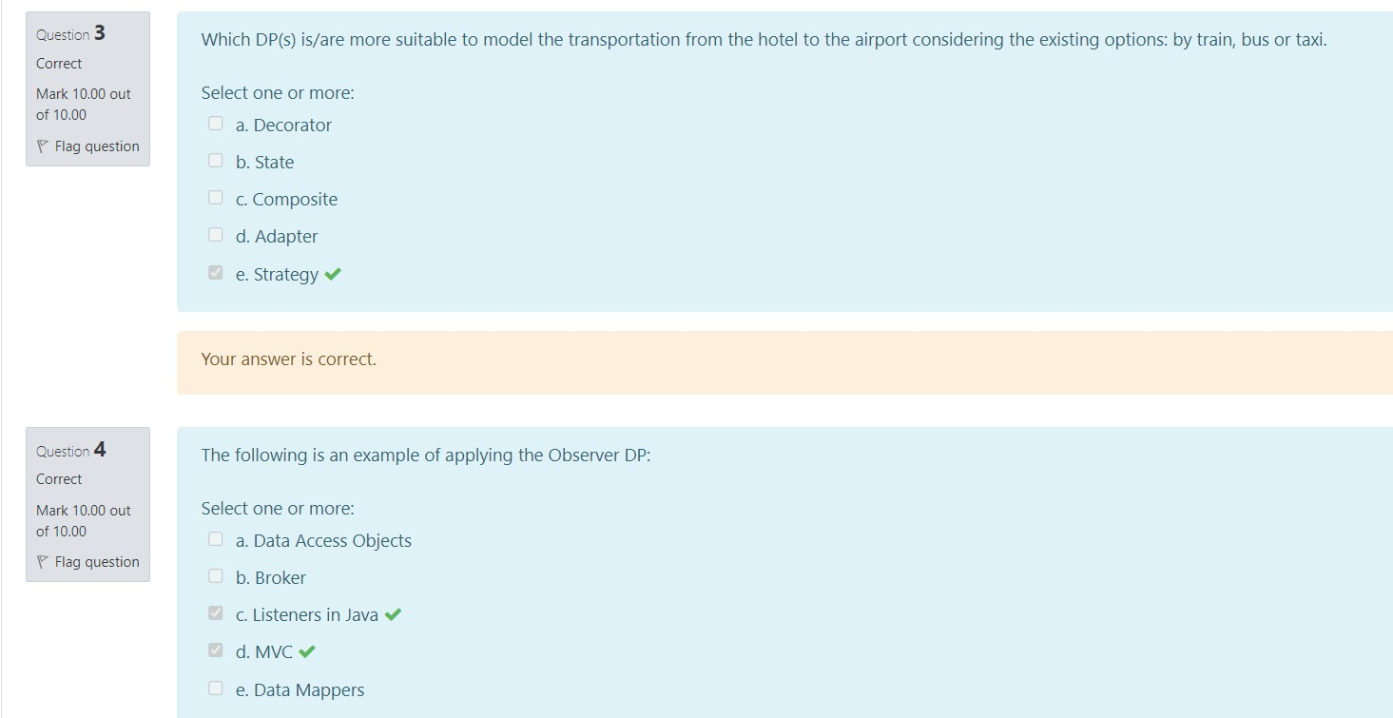
Which DP(s) are more suitable to model the concept of a stock trader
